1. Topic exchange also uses “routing key” for routing messaging but doesn’t require full match. It checks whether the **binding key pattern** of a queue matches the received message’s routing key.
2. Let’s start by creating exchange of type topic.
3. 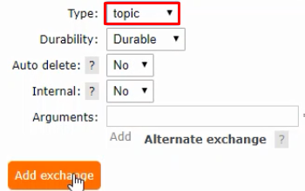
4. 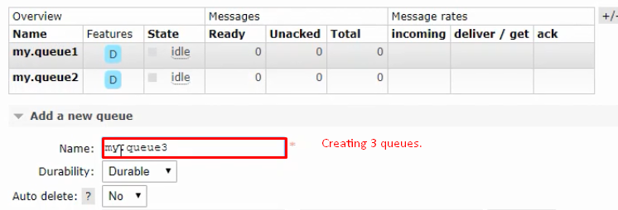
5. 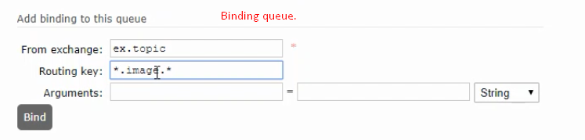
6. 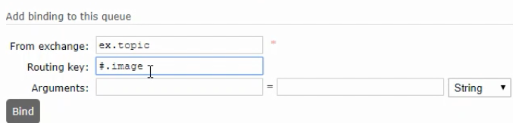
7. 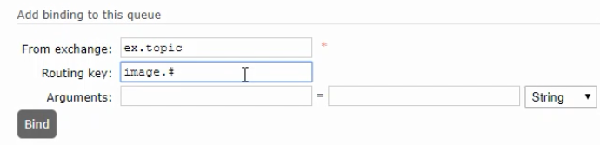
8. 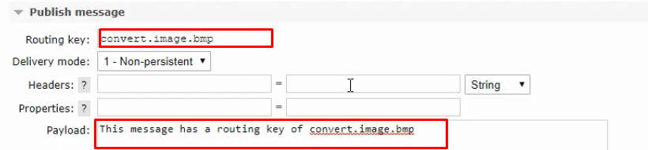  
   The above message will go to the following queue as the message’s routing key matches the queue’s binding route key.  
   
9. 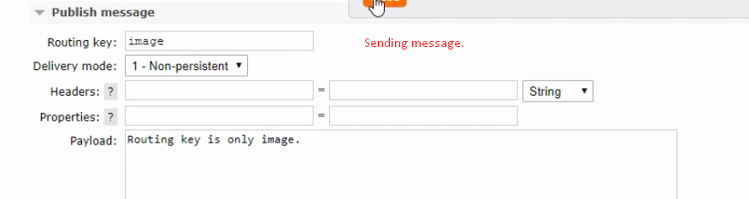
10. 